**Services for next week:**

**Hampton-in-Arden**

**Thursday 16th:**

10am Communion

**Sunday 19th:**

8.15am Common Worship

11am Family Eucharist

6.30pm Evensong

**Bickenhill**

**Sunday 19th**

11am Matins

**Barston**

**Sunday 19th**

9.45am Prayer Time

10.30am Morning Prayer

**Readings for next week**: 1 Corinthians12 v1-11; John 2 v1-11.

**We pray for:** Bob Middleton, David Mort, Mike Beasley, Ann Hall, Tony Worthington, Andrew and Rene Sumner, Derrick Hill, Angela Jones, Mona Cardall, Dot Barton, Richard Herne, Barrie and Mavis Thompson.

Rick Smallwood, Paul Pilkington-Birch, Gloria Stidworthy, Martin Maxfield, Richard Stretton, David Scannell and Colin McDonald.

We also pray for the families of those who have died; Bill Jones, Matthew Hunt, Martin Cox, Audrey Hurdley, Moira Kyles, Coralie Cain and Pamela Wilson.

(Please note, to keep the names of those we pray for up to date, they will be reviewed each month, so if you would like people to be prayed for do let us know at [office@hamptoninardenchurch.org.uk](mailto:office@hamptoninardenchurch.org.uk))

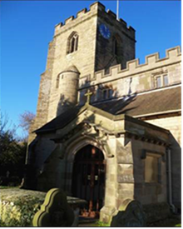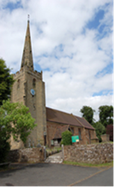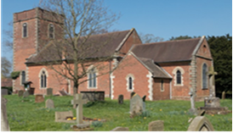

**BARSTON. BICKENHILL. HAMPTON**

**Three Churches Together**

* Sharing God’s Love
* Growing Faith
* Worshipping Together

**12th January 2025 1st Epiphany.**

Acts 8 v14-17; Luke 3 v15-17, 21,22

**Thought for the week**.

At the beginning of Luke’s reading we find the people waiting expectantly and

wondering if… it is good at the start of the new year to be expectant and wondering,

expectant of God’s Blessing and wondering what it might be. So we don’t miss it, we

need eyes open like the apostles in the Acts reading.

The Samaritans had received the good news of Jesus. Peter and John went to pray

for them and God blessed them with the Holy Spirit. The Samaritans were the

cultural, tribal, religious and ethnic enemies of the Jews, the apostles had taken their

blinkers off and saw then as equals, people blessed by God, and brothers and

sisters in Christ. God blessed them both. Question, who are we being asked to

welcome as part of God’s family who we consider ‘not one of us’ and to be blessed

by them?

**SD**

**Collect**

Heavenly Father,

at the Jordan you revealed Jesus as your Son:

may we recognize him as our Lord

and know ourselves to be your beloved children;

through Jesus Christ our Saviour.

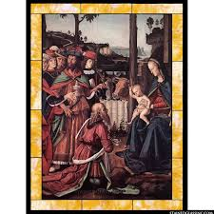

**The Alpha Course** is running at Knowle Church on Wednesday evenings 7.30-9.30pm starting on 22nd January 2025. This provides a chance to freely explore the basics of the Christian faith in an open, friendly environment. Everyone is very welcome. To book e-mail [alpha@kpc.org.uk](mailto:alpha@kpc.org.uk) or phone Knowle Parish Office 01564 779123.



**Hampton**

* **Ladies’ Breakfast** Saturday 18th January 9-10am in the church hall. All welcome!
* **Tea and Toast** Friday 17th January 9-10.15am.
* Help needed to fund a car taking **supplies to Ukraine**, donations to Kim Rawson.
* **Baptism** of Gracie Ellis Sunday 19th 2pm.
* Thanks to Kim for organising the new **church cleaning rota** which started this week. Please let him know if you’d like to join the team.

**Barston**

* **Future date:** Saturday 8th February 11am Craig is being licensed as a Reader at Birmingham Cathedral. Martin, along with many other readers from the diocese will also be at the service as he has been granted the Bishop’s Permission to officiate for the next three years. It would be good to show our support to Craig and Martin and support them by attending the service.
* **Treasurer** – Ian has been our treasurer since 2006 and has done and is still doing a wonderful job. He told the PCC in the Autumn that he intends to retire from the role at the end of this year. He feels it’s the right time for him to hand over the baton of looking after the financial side of the church.

We owe Ian a huge thank you for the way he has carried out this role quietly and most efficiently for almost twenty years. He will work alongside his successor and show them the ropes and support them during the transition.

Please pray that someone will feel called to take on this important role for our church. Meanwhile **ONE BIG THANK YOU** to Ian for all the time you have given behind the scenes in keeping the finances of Church so well ordered.