**Services for next week:**

**Hampton-in-Arden**

**Thursday:**

10am Communion

**Sunday:**

8.15am Common Worship

11am All Age

6.30pm Healing Communion

**Bickenhill**

11am Morning Prayer

**Barston**

9.45 Prayer Time

10.30am All Age Service followed by Bring and Share lunch.

Readings for next week: Jeremiah 33.14-16; Luke 21.25-36

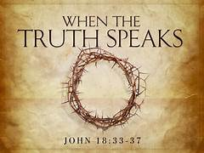

**We pray for:**

Bob Middleton, David Mort, Mike Beasley, Ann Hall, Tony Worthington, Paul Pilkington-Birch, Kayleigh McGeoch, Andrew and Rene Sumner, Michelle Cox, Rick Smallwood, Derrick Hill, Colin McDonald, David Scannell, Angela Jones, Mona Cardall, Val Sharp, Gloria Stidworthy, Gordon and Doreen Morris, Ian Houston, Robin Tarplin, Mathew Read,Martin Maxfield, Dot Barton and Richard Stretton.

We also pray for the families of those who have died; Rose Cookes, Ian Rayney, Bill Jones, Matthew Hunt, Martin Cox, Audrey Hurdley and Moira Kyles.

(Please note, to keep the names of those we pray for up to date, they will be reviewed each month, so if you would like people to be prayed for do let us know at [office@hamptoninardenchurch.org.uk](mailto:office@hamptoninardenchurch.org.uk))

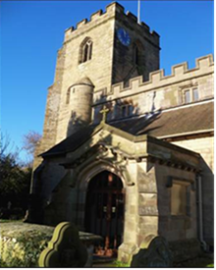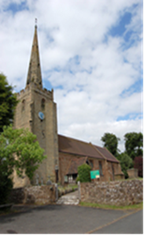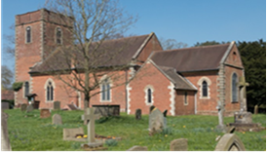

**BARSTON. BICKENHILL. HAMPTON**

Three Churches Together

* Sharing God’s Love
* Growing Faith
* Worshipping Together

**24th November 2024 Christ the King.**

Daniel 7. 9-10,13, 14 John 18. 33-37

**Thought for the week**.

**Truth vs Falsehood**

How often are we given a false story – for political advantage, for economic profit, for sheer greed, for self praise and an inflated ego? Fake news. How can we believe and trust the leaders in our society, our establishment? So often leaders are found to be lacking integrity and truth, and we

realise when the scandal erupts that we have been led up the garden path.

As John introduced Jesus at the beginning of his gospel:

‘The Word became flesh and made his dwelling among us. We have seen his glory, the glory of the one and only Son, who came from the Father, full of grace and truth.’ (John 1:14)

Jesus is the only truth. So as he said to Pilate “Everyone on the side of truth listens to me” (John 18:37). He was, and is, and is to come, the only truth. Come, and follow him. Christ the King.

**Collect**

God the Father,

help us to hear the call of Christ the King

and to follow in his service,

whose kingdom has no end;

for he reigns with you and the Holy Spirit,

one God, one glory.

**Hampton**

* After the 11am service there will be the blessing of the bellringers bench. All are welcome to join us outside.
* Huge thanks to Roger Waring who is kindly repairing our hymn books. A huge job which will enable them to be used and enjoyed for years to come.
* **Chronicle Distributors meeting** at 6.30pm on Thursday 28th in the church hall.
* **Tea and Toast** Friday 29th at9am.
* **Christmas Fayre** – please help by donating new Christmas themed tombola prizes, mince pies, posh biscuits, wrapped sweets and especially **unopened cosmetics and beauty products that can be wrapped and sold as a ready made gift**. Donations can be left at the back of church.
* Everyone who is a member of the Church needs to complete Basic Awareness Safeguarding Training, whatever your role. This includes roles like serving, flower arranging, choir, cleaning, reading, making the refreshments as well the more obvious roles like helping with Children’s Church. All training is online since Covid but is easy to access. Log onto https://safeguardingtraining.cofeportal.org and follow the instructions. If you would like some help please ask Anna or Vickki. Most people completing the module find it interesting and helpful. Abuse is much more complex than many realise, and we all have an important part to play in keeping our Church safe so all can thrive and be loved.
* **Church cleaning rota** for Jan-June 2025 Please text or e-mail Kim Rawson on 07527540529 or [kim.rawson@btinternet.com](mailto:kim.rawson@btinternet.com) if you can help. Also, could current cleaning teams please confirm you are happy to continue.
* We are collecting Christmas costumes to create a dressing up box for use at the Christmas trail or for the crib service for those children who may not have an outfit. Please keep an eye out in charity shops!
* Please contact Kim if you would like to read at the Nine Lessons and Carols (Sunday 22nd December at 4pm). As always, it would be lovely to have “new” readers but Kim will compile a list of anyone keen to help out! His details are above.
* The new rota for 11am services for the first quarter of 2025 has been e-mailed out and is on the notice board in church. Thanks to all who offer their time to help in services.

**Barston**

* The **Christmas cards** for the village are now available in church. They have been bundled for each person who kindly delivered a specific road last year. If they can now be delivered as quickly as possible that would be much appreciated. There are spare cards so please take one for yourselves. A big **Thank you** to Paul and Vivian for taking the initiative and organizing the layout and printing of the cards.
* **Church Christmas Post**. The post box will be put out on the morning of 8th December. This will be the only date. If you prefer, can we suggest that you send one card addressed to the whole church and with the money you have saved make a donation in lieu of buying cards. We have decided to put a box for donations by the post box and the money will go to the Parkinson Society. Obviously this is a personal choice.
* **Rota** for the first quarter of 2025 has been e-mailed out and paper copies available on the table. Many thanks to those who put this together and to everyone willing to help out to make our services happen.
* PRAYER DIARY for December on table.
* Wednesday November 27th Eastcote Park service of Holy Communion 11am.
* **Romans Course** session 10 7pm at home of Paul and Vivian.
* **Future date**- 6th December from 10am Decorating the church for Christmas. Volunteers needed to decorate the Christmas tree, flower arrangements and do the notice board.