**Services for next week:**

**Hampton-in-Arden**

**Thursday 23rd:**

10am Communion

**Sunday 26th:**

8.15am BCP

11am Eucharist

6.30pm Study

**Bickenhill**

**Sunday 26th**

11am Eucharist

**Barston**

**Sunday 26th**

9.45am Prayer Time

10.30am Holy Communion where we welcome Rev Paul Hinton

**Readings for next week**: 1 Corinthians12 v12-31a; Luke 4 v14-21.

**We pray for:** Bob Middleton, David Mort, Mike Beasley, Ann Hall, Tony Worthington, Andrew and Rene Sumner, Derrick Hill, Angela Jones, Mona Cardall, Dot Barton, Richard Herne, Barrie and Mavis Thompson.

Rick Smallwood, Paul Pilkington-Birch, Gloria Stidworthy, Martin Maxfield, Richard Stretton, David Scannell and Colin McDonald.

We also pray for the families of those who have died; Bill Jones, Matthew Hunt, Martin Cox, Audrey Hurdley, Moira Kyles, Coralie Cain, Pamela Wilson and Celia Heron.

(Please note, to keep the names of those we pray for up to date, they will be reviewed each month, so if you would like people to be prayed for do let us know at [office@hamptoninardenchurch.org.uk](mailto:office@hamptoninardenchurch.org.uk))

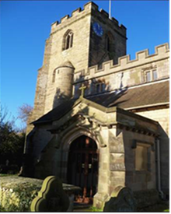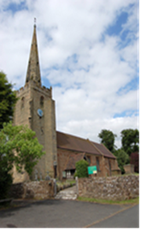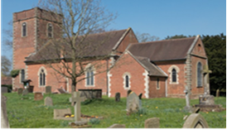

**BARSTON. BICKENHILL. HAMPTON**

**Three Churches Together**

* Sharing God’s Love
* Growing Faith
* Worshipping Together

**19th January 2025 2nd Epiphany.**

1 Corinthians12 v1-11; John 2 v1-11.

**Thought for the week**.

Most Christians are positively concerned about the Holy Spirit being in our lives. How do I know when I’m living close to the LORD? What makes a person really spiritual? Is it that he or she prays a lot? Is it mastery of Scripture, or power in preaching? Who should be the spiritual leaders in our

congregation? How can we recognise them? Can even I live a truly spiritual life? If so, how?

All these questions, and more like them, are answered by the apostle Paul in this passage. If you’re hungry for more spirituality, this passage will feed your

soul. The passage explains how the gifts described have a common origin, but are handed out one by one by the one Spirit of God and He does that for the members of the Church. The members of a church can be thought about being like your own body. Your body has many parts—limbs, organs,

cells—but no matter how many parts you can name, you’re still one body. It’s exactly the same with the Church which is the body of Christ. We are even given special spiritual gifts from time to time, to be used when we come together for worship, prayer and ministry. **MM**

**Collect**

Eternal Lord,

our beginning and our end:

bring us with the whole creation

to your glory, hidden through past ages

and made known

in Jesus Christ our Lord.

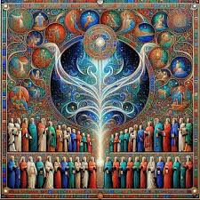

**The Alpha Course** is running at Knowle Church on Wednesday evenings 7.30-9.30pm starting on 22nd January 2025. This provides a chance to freely explore the basics of the Christian faith in an open, friendly environment. Everyone is very welcome. To book e-mail [alpha@kpc.org.uk](mailto:alpha@kpc.org.uk) or phone Knowle Parish Office 01564 779123.

**FILLING STATION**

Restarts on Monday February 3rd. Speaker is Professor David Cheetham. David preached at Barston several times last year and he is a wonderful speaker unpacking Biblical truths in an easily relatable way. Great worship and teaching in our local area – Knowle Village Hall 7pm for 7.30pm start. Again if you’ve never been, maybe this year you will consider popping along as this promises to be a very special evening.

**Hampton**

* Our **Table Top Sale** was a great morning of fundraising with community and church coming together. Thanks to all who helped and attended, especially Vickki and Priscilla for co-ordinating us all! Together we raised over £160 for the church.
* Date for the diary – our next fundraising event will be a **Lenten Frugal Lunch** on Sunday 16th March. More details to follow!
* Helpers needed to welcome at baptisms, please. You would probably only be asked to help once or twice a year and it takes approx. an hour and a half on either a Sat or Sun afternoon. These are always very cheerful occasions and a great help to Stuart, or whoever else is taking the service. Please contact Debby Read on….[debbyread@hotmail.co.uk](mailto:debbyread@hotmail.co.uk) many thanks!
* Many thanks to those who contributed to our collection to **The Children’s Society**. We raised a total of £199.50
* **Tea and Toast** Friday 24th January 9-10.15am.

**Barston**

* St Swithin’s House Tuesday 21st January **Hobby House** 10am-12 noon. Same place and date for **Tea Club** at 2pm where we are celebrating several birthdays. Always a warm welcome at both events. Perhaps give us a try in this New Year.
* Wednesday 22nd January **Service at Eastcote Park** at 11am. All are welcome. It would be good to support those from our fellowship that take services there. You would be most welcome.There’s a chance to chat to residents afterwards over a cuppa too.
* **BIRMINGHAM CATHEDRAL.** Saturday 8th February Licensing Service at 11am of new Lay Readers and re-dedication on existing Lay Readers. Craig will be licensed and Martin will have his permission to officiate renewed – this happens every three years when you reach 70. We really hope you will be able to go along to support them both. Please pray for them both too.
* **St Swithin’s House** is having some redecorating done next week. Some bedrooms are being painted.